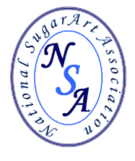 West Wickham Sugarcraft Club
(Affiliated to the National SugarArt Association)
Programme March 2021– February 2022
Facebook - West Wickham Sugarcraft
Please search: West Wickham Sugar Craft Official
ALL members will receive an email invitation to the Zoom demonstrations. The meetings will open at 7pm and the demo will start at 7.30pm. PLEASE log in by 7.25pm for a prompt 7.30pm start.
23rd February | Carolyn Harvey |  | Novelty dressed chick and patchwork cutters
9th March | Ann Wilson |  | Modelling Chocolate
6th April | Stephen Benison |  | Creative Ideas for Celebration and Wedding Cakes  "Thinking outside the box “
11th May | Ben Fullard |  | ‘Something Floral’ seasonal flowers  Parrot Tulips
9th June | Rhianydd Webb | 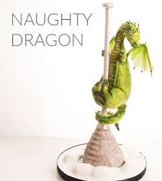 | Cute Dragon cake topper
7th July | Sidney Galpern (USA) | 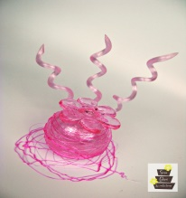 | Isomalt – uses and ideas
10th August | Daniel Guiriba  (Phillipines) |  | Wafer Paper Roses and Leaves
14th September | Emily Hankins | 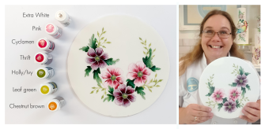 | Cocoa Butter Painting
5th October | Tanya Ross (IRE) |  | Airbrushing and cake board decorating.
November | TBC

